BS 851

Homework 8

Irene Hsueh

**Question 1**

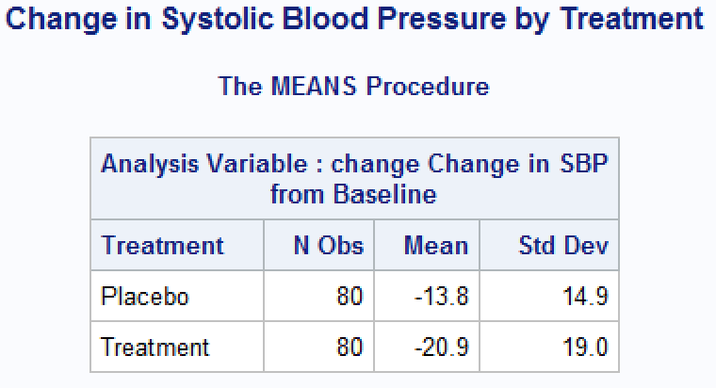

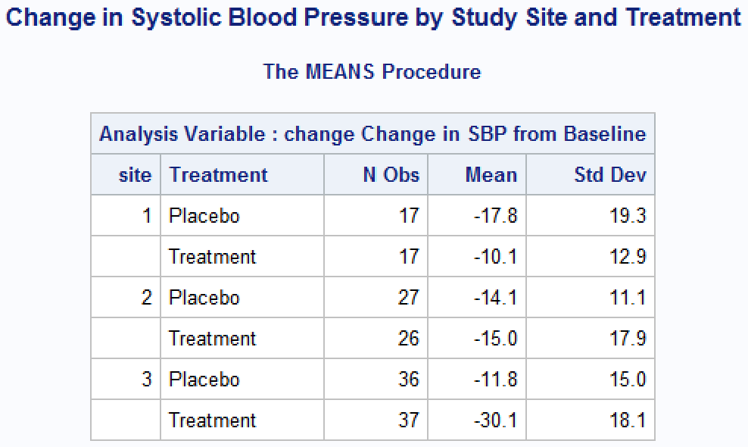

There appears to be some potential effect modification from study center because the treatment effect greatly differs between study sites. The average SBP decrease at center 3 was three times as much as the decrease at center 1 and twice as much as the decrease at center 2.

**Question 2**

An unadjusted linear regression analysis was used to test whether change in SBP from baseline was linearly associated with treatment. The F-statistic was 6.91 with 1 and 158 degrees of freedom, and the resulting p-value was 0.0094. With a p-value less than the α=0.05 significance level, the null hypothesis of there being no linear association between change in SBP and treatment was rejected. There is evidence suggesting that the linear association is

$$SBPchange=-13.8375-7.0875trtN$$

An adjusted multiple linear regression analysis was used to test whether change in SBP from baseline was linearly associated with treatment and study center. The F-statistic was 4.42 with 2 and 157 degrees of freedom, and the resulting p-value was 0.0052. With a p-value less than the α=0.05 significance level, the null hypothesis of there being no linear association between change in SBP and treatment was rejected. There is evidence suggesting that the linear association is

$$SBPchange=-17.4753-7.0082trtN+7.0382site1+6.3472site2$$

The results do not change significantly when adjusting for study center. Both regression analysis show that the new treatment decreases SBP by at least 7 mmHg.

**Question 3**

H0: There is no interaction between treatment and study center.

HA: There is interaction between treatment and study center.

A multiple linear regression analysis was used to test whether change in SBP from baseline was linearly associated with the interaction between treatment and study center. The F-statistic was 9.06 and the resulting p-value was 0.0002. With a p-value less than the α=0.15 significance level, the null hypothesis of there being no linear association between change in SBP and the interaction between treatment and study center was rejected. There is evidence suggesting that the linear association is $$SBPchange=-11.7500-18.3041trtN-6.0147site1-2.3981site2+25.9511trtNsite1+17.4522trtNsite2$$

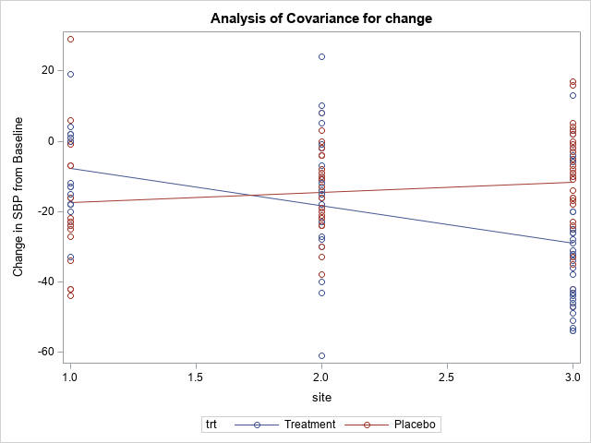

The interaction is significant and is qualitative.

**Question 4**

H0: There is no interaction between treatment and study center.

HA: There is interaction between treatment and study center.

A multiple linear regression analysis using dummy variables was used to test whether change in SBP from baseline was linearly associated with the interaction between treatment and study center. For the interaction between treatment and study center 1, the F-statistic was 15.20 and resulting p-value was 0.0001. For the interaction between treatment and study center 2, the F-statistic was 9.10 and resulting p-value was 0.0030. With p-values less than the α=0.15 significance level, the null hypothesis of there being no linear association between change in SBP and the interaction between treatment and study center was rejected. There is evidence suggesting that the linear association is $$SBPchange=-11.7500-18.3041trtN-6.0147site1-2.3981site2+25.9511trtNsite1+17.4522trtNsite2$$

**Question 5**

treatment and site 1 $E\left[Y\right]=-11.7500-18.3041-6.0147+25.9511$-10.1177

treatment and site 2 $E\left[Y\right]=-11.7500-18.3041-2.3981+17.4522$-15

treatment and site 3 $E\left[Y\right]=-11.7500-18.3041$-30.0541

placebo and site 1 $E\left[Y\right]=-11.7500-6.0147$-17.7647

placebo and site 2 $E\left[Y\right]=-11.7500-2.3981$-14.1481

placebo and site 3 $E\left[Y\right]=-11.7500$-11.7500

These predicted values are exactly the same as the mean values calculated in question 1, which makes sense because the regression analysis came up with the best parameters that fit the inputted data. The interaction term between treatment and study center was significant because the treatment effect differed between study centers.

**Question 6**

Three linear regression analyses were used to test whether change in SBP from baseline was linearly associated with treatment at each of the three study centers.

For study center 1, the F-statistic was 1.85 with 1 and 32 degrees of freedom, and the resulting p-value was 0.1835. For study center 2, the F-statistic was 0.04 with 1 and 51 degrees of freedom, and the resulting p-value was 0.8353. With p-values less than the α=0.05 significance level, the null hypothesis of there being no linear association between change in SBP and treatment was not rejected. There is insufficient evidence to suggest the new treatment is more effective than the placebo at decreasing SBP at study centers 1 and 2.

At study center 3, the F-statistic was 21.99 with 1 and 71 degrees of freedom, and the resulting p-value was <0.0001. With a p-value less than the α=0.05 significance level, the null hypothesis of there being no linear association between change in SBP and treatment was rejected. There is evidence suggesting that at study center 3, the linear association is

$$SBPchange=-11.7500-18.3041trtN$$

It is recommended that those with hypertension go to study center 3 to get effective treatment.

**Question 7**

|  |  |  |  |
| --- | --- | --- | --- |
| Overall Sample | **No CVD** | **CVD** | Total |
| **Placebo** | 64 (80%) | 16 (20%) | 80 |
| **Treatment** | 75 (95%) | 4 (5%) | 80 |
| Total | 140 | 20 | 160 |

|  |  |  |  |
| --- | --- | --- | --- |
| Male | **No CVD** | **CVD** | Total |
| **Placebo** | 34 (80.95%) | 8 (19.05%) | 42 |
| **Treatment** | 39 (97.50%) | 1 (2.5%) | 40 |
| Total | 73 | 9 | 82 |

|  |  |  |  |
| --- | --- | --- | --- |
| Female | **No CVD** | **CVD** | Total |
| **Placebo** | 30 (78.95%) | 8 (21.05%) | 38 |
| **Treatment** | 37 (92.50%) | 3 (7.50%) | 40 |
| Total | 67 | 11 | 78 |

There doesn’t seem to be potential interaction due to sex because the percentage of those who developed CVD in the placebo and treatment group appear to be similar among males and females.

**Question 8**

A Breslow-Day-Tarone test was used to test whether there was interaction between treatment and sex on cardiovascular disease. The chi-squared score was 0.6485 with 1 degree of freedom, and the resulting p-value was 0.4206. With a p-value greater than the α=0.05 significance level, the null hypothesis of no interaction between treatment and sex on cardiovascular disease was not rejected. There is insufficient evidence to conclude that the effect of treatment on cardiovascular disease differs between male and females.

**Question 9**

A chi-squared test was used to test whether there was an association between treatment and cardiovascular disease. The chi-squared statistic was 8.2286 with 1 degree of freedom and the resulting p-value was 0.0041. With a p-value less than the α=0.05 significance level, the null hypothesis of there being no association between treatment and cardiovascular disease was rejected. There is evidence suggesting that those who received the new treatment had 0.2105 times the odds of the cardiovascular disease compared to those who received the placebo (95% confidence interval: 0.0670, 0.6616).

**Question 10**

A multiple logistic regression analysis was used to test whether the risk of cardiovascular disease was associated with the interaction between treatment and sex. From the Wald test, the F-statistic was 0.6196 and resulting p-value was 0.4312. With a p-value greater than the α=0.15 significance level, the null hypothesis of there being no association between cardiovascular disease and interaction between treatment and sex was not rejected. There is insufficient evidence to conclude that the effect of treatment on cardiovascular disease differs between male and females.

**Question 11**

The proc logistic performs a logistic regression while the proc freq function performs a chi-squared test. A logistic regression will perform a likelihood ratio test to see if the overall model is useful. If at least one parameter is not 0, then there is an association between the outcome variable and at least one of the predictors. A chi-squared test can only handle one categorical predictor variable, while a logistic regression can incorporate multiple covariates, some of which can be continuous. A logistic regression will also perform Wald tests for each predictor, not just the interaction term, so you can see the significance of each covariate.